**Academic Year: 2023-24 Name of Student:**

**Semester: III Student ID:**

**Class / Branch/ Div: SE- IT A/ B/ C Roll No.**

**Subject: Data Structure Lab Date of Submission:**

**Name of Instructor:**

**Experiment No.3**

**Aim: To implement insertion,deletion operations with singly linked list**

# Code:

**#include <stdio.h>**

**#include <stdlib.h>**

**#include <malloc.h>**

**struct node**

**{**

**int data;**

**struct node *next;**

**};**

**struct node *start = NULL;**

**struct node *create_ll(struct node *);**

**struct node *display(struct node *);**

**struct node *insert_beg(struct node *);**

**struct node *delete_end(struct node *);**

**int main(int argc, char *argv[]) {**

**int option;**

**do**

**{**

**printf("\n\n *****MAIN MENU *****");**

**printf("\n 1: Create a list");**

**printf("\n 2: Display the list");**

**printf("\n 3: Add a node at the beginning");**

**printf("\n 4: Delete a node from the end");**

**printf("\n 5: EXIT");**

**printf("\n\n Enter your option : ");**

**scanf("%d", &option);**

**switch(option)**

**{**

**case 1: start = create_ll(start);**

**printf("\n LINKED LIST CREATED");**

**break;**

**case 2: start = display(start);**

**break;**

**case 3: start = insert_beg(start);**

**break;**

**case 4: start = delete_end(start);**

**break;**

**}**

**}while(option !=13);**

**return 0;**

**}**

**struct node *create_ll(struct node *start)**

**{**

**struct node *new_node, *ptr;**

**int num;**

**printf("\n Enter -1 to end");**

**printf("\n Enter the data : ");**

**scanf("%d", &num);**

**while(num!=-1)**

**{**

**new_node = (struct node*)malloc(sizeof(struct node));**

**new_node -> data=num;**

**if(start==NULL)**

**{**

**new_node -> next = NULL;**

**start = new_node;**

**}**

**else**

**{**

**ptr=start;**

**while(ptr->next!=NULL)**

**ptr=ptr->next;**

**ptr->next = new_node;**

**new_node->next=NULL;**

**}**

**printf("\n Enter the data : ");**

**scanf("%d", &num);**

**}**

**return start;**

**}**

**struct node *display(struct node *start)**

**{**

**struct node *ptr;**

**ptr = start;**

**while(ptr != NULL)**

**{**

**printf("\t %d", ptr -> data);**

**ptr = ptr -> next;**

**}**

**return start;**

**}**

**struct node *insert_beg(struct node *start)**

**{**

**struct node *new_node;**

**int num;**

**printf("\n Enter the data : ");**

**scanf("%d", &num);**

**new_node = (struct node *)malloc(sizeof(struct node));**

**new_node -> data = num;**

**new_node -> next = start;**

**start = new_node;**

**return start;**

**}**

**struct node *delete_end(struct node *start)**

**{**

**struct node *ptr, *preptr;**

**ptr = start;**

**while(ptr -> next != NULL)**

**{**

**preptr = ptr;**

**ptr = ptr -> next;**

**}**

**preptr -> next = NULL;**

**free(ptr);**

**return start;**

**}**

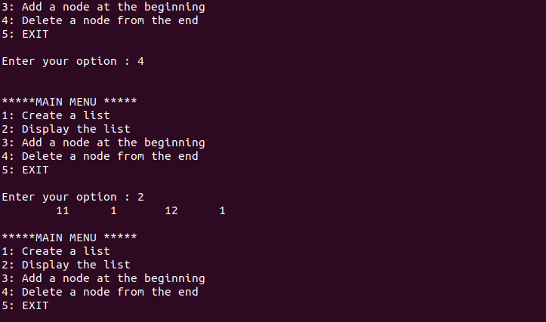

# Conclusion: -Thus, we have iinserted and deleted node in linklist. In the linked list we dynamically allocate the memory to the node and keep the track of the next node.